// Design a system for doors at home, such that whenever a door is opened, a light turns on for 1000 ms if it is day & 2000 ms if it is night.

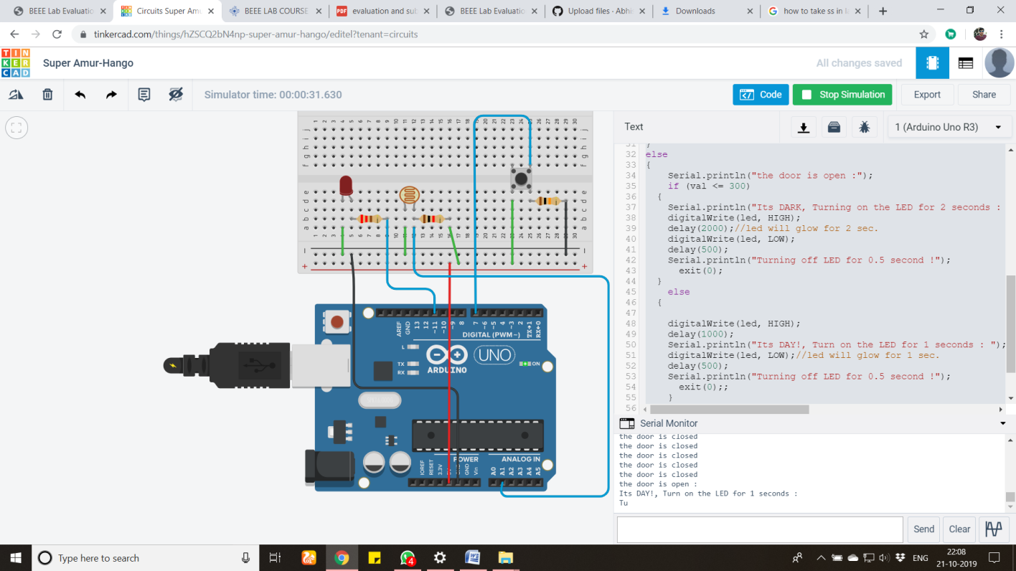

const int led = 11;

const int buttonPin = 7;

int buttonState = 0;

int flag=0;

const int Ldr = A0;

void setup() {

Serial.begin(9600);

pinMode(led, OUTPUT);

pinMode(Ldr, INPUT);

pinMode(buttonPin, INPUT);

}

void loop()

{

buttonState = digitalRead(buttonPin);

int val = analogRead(Ldr);

if (buttonState == LOW)//check door is open or not.

{

Serial.println("the door is closed");

}

else

{

Serial.println("the door is open :");

if (val <= 300)

{

Serial.println("Its DARK, Turning on the LED for 2 seconds : ");

digitalWrite(led, HIGH);

delay(2000); //led will glow for 2 sec.

digitalWrite(led, LOW);

delay(500);

Serial.println("Turning off LED for 0.5 second !");

exit(0);

}

else

{

digitalWrite(led, HIGH);

delay(1000);

Serial.println("Its DAY!, Turn on the LED for 1 seconds : ");

digitalWrite(led, LOW);//led will glow for 1 sec.

delay(500);

Serial.println("Turning off LED for 0.5 second !");

exit(0);;

}

}

}